**Quality Improvement Transformational Checklist**

**Purpose:** The purpose of this checklist is to ensure there is a sequential process in place to support and validate implementation of a new/revision/refinement in a system at the facility; to provide updated feedback to Managers/Leaders who offer supports on any changes so that support is provided timely to facilitate rapid improvements in care areas that require immediate correction to avoid negative care outcomes.

**Guidance:** Administrator/Director of Nursing will initiate the check list and submit to QAA team to review and address any areas of needed support. If QAA team are unable to provide solutions or support, the checklist will submit the same day received to Corporate Services. Regional will submit a progress weekly report until System implementation is confirmed successful via PIP measurable goals. Transformational Model comes from EBP resources and research.

**Facility Name:**

**The System/Care Area of Improvement: Projected Date of implementation:**

|  |  |  |
| --- | --- | --- |
| **Phases of Behavioral Change** | **YES** | **NO** |
| **Pre-contemplation Phase**  Identifying issues/problems: discussed with Medical Director, & IDT with Educational Material provided & data (copies of recent citations, grievance log/incident log reviewed for trends; staffing concerns/supply concerns, regional/ consultant reports). IDT in agreement that change is needed/necessary & initiate QAPI Binder for PIP & place all data collected & educational material presented in binder including minutes from meetings. Administrator will maintain Binder for Regional Visits |  |  |
| **Contemplation Phase**  PIP (line staff engagement & resident engagement)  PIP Completed with Team Commitment Established with a 3- month Calendar Posted for All Staff & integrated into Employee communication systems (staff meetings, PCC Bulletin, newsletters, etc.,) |  |  |
| **Preparation Phase**  Identify all communications System for implementation, Policies, Forms, Environment, all/any resources needed evaluated and included in PIP weekly discussion to ensure realist goals that are measurable are established. PIP plan approved by Administration demonstrating readiness for action with PIP signed and dated and submitted to Corp. |  |  |
| **Action Phase**  Integration into current systems with ongoing training and feedback process to PIP committee. Provide positive feedback and PIP reports printed for Staff to validate progress (ongoing support strategies for the role out outlined on PIP). |  |  |
| **Maintenance Phase**  PIP reviewed by QA Committee with QA committee feedback and support/suggestions.  Celebration of sustaining progress and learning |  |  |
| **Evaluation Phase**  Validation process that system/change is sustained by review of audits/data identified in PIP and submitted to Regional with analysis and summary to determine if ongoing PIP is necessary |  |  |

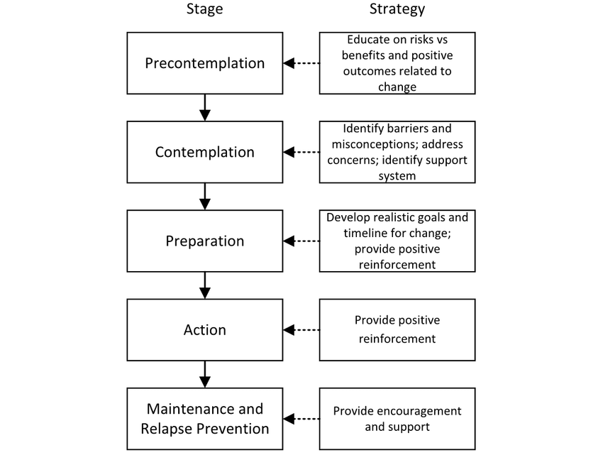

**List any Missing Areas/Phases:**

________________________________________________________________________________________________________________________________________________________________________________**Recommendations**:__________________________________________________________________________________________________________________________________________

**(Example) Quality Improvement Transformational Checklist**

**Purpose:** The purpose of this checklist is to ensure there is a sequential process in place to support and validate implementation of a new/revision/refinement in a system at the facility; to provide updated feedback to Managers/Leaders who offer supports on any changes so that support is provided timely to facilitate rapid improvements in care areas that require immediate correction to avoid negative care outcomes.

**Guidance:** Administrator/Director of Nursing will initiate the check list and submit to QAA team to review and address any areas of needed support. If QAA team are unable to provide solutions or support, the checklist will submit the same day received to Corporate Services. Regional will submit a progress weekly report until System implementation is confirmed successful via PIP measurable goals. Transformational Model comes from EBP resources and research.

**Facility Name:**

**The System/Care Area of Improvement: *Providing Supervised Smoking* Projected Date of implementation: 8/2/2023**

SAMPLE

|  |  |  |
| --- | --- | --- |
| **Phases of Behavioral Change** | **YES** | **NO** |
| **Pre-contemplation Phase**  Identifying issues/problems: discussed with Medical Director, & IDT with Educational Material provided & data (copies of recent citations, grievance log/incident log reviewed for trends; staffing concerns/supply concerns, regional/ consultant reports). IDT in agreement that change is needed/necessary & initiate QAPI Binder for PIP & place all data collected & educational material presented in binder including minutes from meetings. Administrator will maintain Binder for Regional Visits | **√** |  |
| **Contemplation Phase**  PIP (line staff engagement & resident engagement)  PIP Completed with Team Commitment Established with a 3- month Calendar Posted for All Staff & integrated into Employee communication systems (staff meetings, PCC Bulletin, newsletters, etc.,) |  | **√** |
| **Preparation Phase**  Identify all communications System for implementation, Policies, Forms, Environment, all/any resources needed evaluated and included in PIP weekly discussion to ensure realist goals that are measurable are established. PIP plan approved by Administration demonstrating readiness for action with PIP signed and dated and submitted to Corporation QA leaders. |  | **√** |
| **Action Phase**  Integration into current systems with ongoing training and feedback process to PIP committee. Provide positive feedback and PIP reports printed for Staff to validate progress (ongoing support strategies for the role out outlined on PIP). | **√** |  |
| **Maintenance Phase**  PIP reviewed by QA Committee with QA committee feedback and support/suggestions.  Celebration of sustaining progress and learning |  | **√** |
| **Evaluation Phase**  Validation process that system/change is sustained by review of audits/data identified in PIP and submitted to Regional with analysis and summary to determine if ongoing PIP is necessary |  | **√** |



**List any missing Areas/ Phases:**

1. New Assessment proposed in EMR does not match policy. Facility can only provide supervised smoking and not help with assistance.

2. PIP committee has not been established

3. Inaccurate smoking assessments

**Recommendations:**

1. Next week have PIP committee established & weekly calendar.
2. Training on smoking assessment complete by 7/22
3. HIM to update assessment in EMR by 7/22