**(Add your own Logo Here)**

**(Add & Connect your team to the Vision, Mission, or Value Statement/s)**

**Sample Add your own message**

**Dear Team,**

**During this month we take time to teach and remember the importance of handwashing not only as caregivers but also in other roles we have in our families and communities. There is always an opportunity to practice our values and this month let’s make certain we are reliable examples of infection preventionist and we foster education through teaching good handwashing to our residents and supporting these efforts with our colleagues and in our various roles in the community. There is also a new reporting list from issued by our State on reportable diseases. Please check it out** [**https://doh.wa.gov/public-health-healthcare-providers/notifiable-conditions/list-notifiable-conditions**](https://doh.wa.gov/public-health-healthcare-providers/notifiable-conditions/list-notifiable-conditions) **and you can also sign up to get updates on this site too. I wish you and your loved ones all a great holiday season. Thank you for everything you do to foster the values of our organization.**

**Happy Holidays! ~**

**December 2022**

**Handwashing Awareness**

World AIDS Day

National Influenza Vaccination Week

National Hand Washing Awareness Week

Christmas Seals Campaign

Jingle Bell Run for Arthritis Month

**CELEBRATE YOUR COLLEAGUES!**

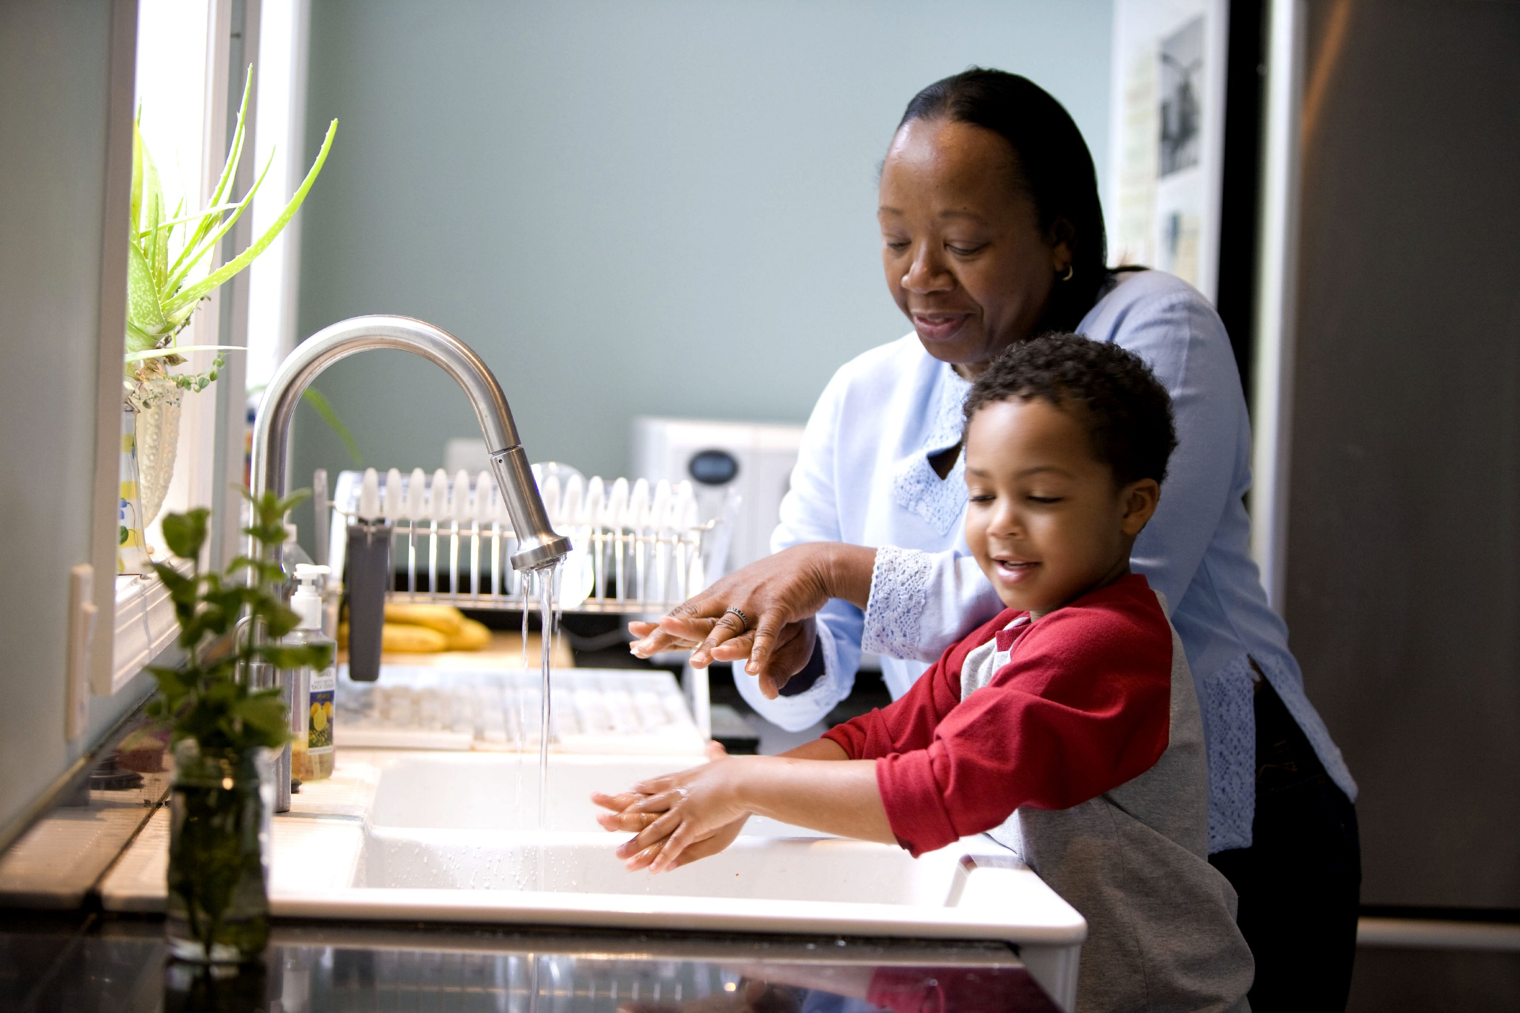

♥ ♥ ♥ ♥ ♥ ♥ ♥ ♥ ♥

**Checking Your Knowledge/Self-Study Activity**: please answer the questions as you research the following website and turn into (insert staffing educator name) when completed.

* What are the 5 points of Handwashing? <https://www.who.int/teams/integrated-health-services/infection-prevention-control/hand-hygiene>
* Check out the new upgraded **American Disability Act** (ADA) website by going <https://www.ada.gov/>

Then answer the following question: what are some ways people with physical challenges communicate? What does it tell you about COVID19 and the Disability Act?

* Check out the Arthritis Foundation Website and write one thing you learned about inflammation <https://www.arthritis.org/health-wellness/about-arthritis/related-conditions/physical-effects/inflammation-and-the-immune-system>
* Research and answer the following question: What health care organization does Christmas Seals support this year 2022?