**◊◊◊** (insert your log) **◊◊◊**

**(**Connect to Values/Vision/Mission Statements insert here)

(insert your own message here)

**Could you draw all the structures of the brain? Could you explain to your resident or family which parts of the brain may be responsible for swallowing and speech challenges? Let’s sharpen and refresh our anatomy and physiology knowledge and skill this month as we study Myasthenia Gravis and Brain Awareness to put this knowledge into therapeutic communication strategies for providing compassionate care to those who have conditions or diseases that effect the function of the brain or nervous system.**

**Start by drawing or sketching the human brain on a piece of paper and recall what you do remember from you studies about dementia or the brain anatomy. Below are some resources if you are not able to recall specifics to outline your drawing.**

[**https://portal.brain-map.org/explore/seattle-alzheimers-disease**](https://portal.brain-map.org/explore/seattle-alzheimers-disease)

[**https://mayfieldclinic.com/pe-anatbrain.htm**](https://mayfieldclinic.com/pe-anatbrain.htm)

**JUNE 2023**

**Alzheimer’s & Brain Awareness Month**

**Aphasia Awareness Month**

**Myasthenia Gravis Awareness Month**

Cataract Awareness Month

Hernia Awareness Month

National Safety Month

PTSD Awareness month

**CELEBRATE YOUR COLLEAGUES!**

National Career Nursing Assistants’ Day

National Nursing Assistants Week 6/16-22



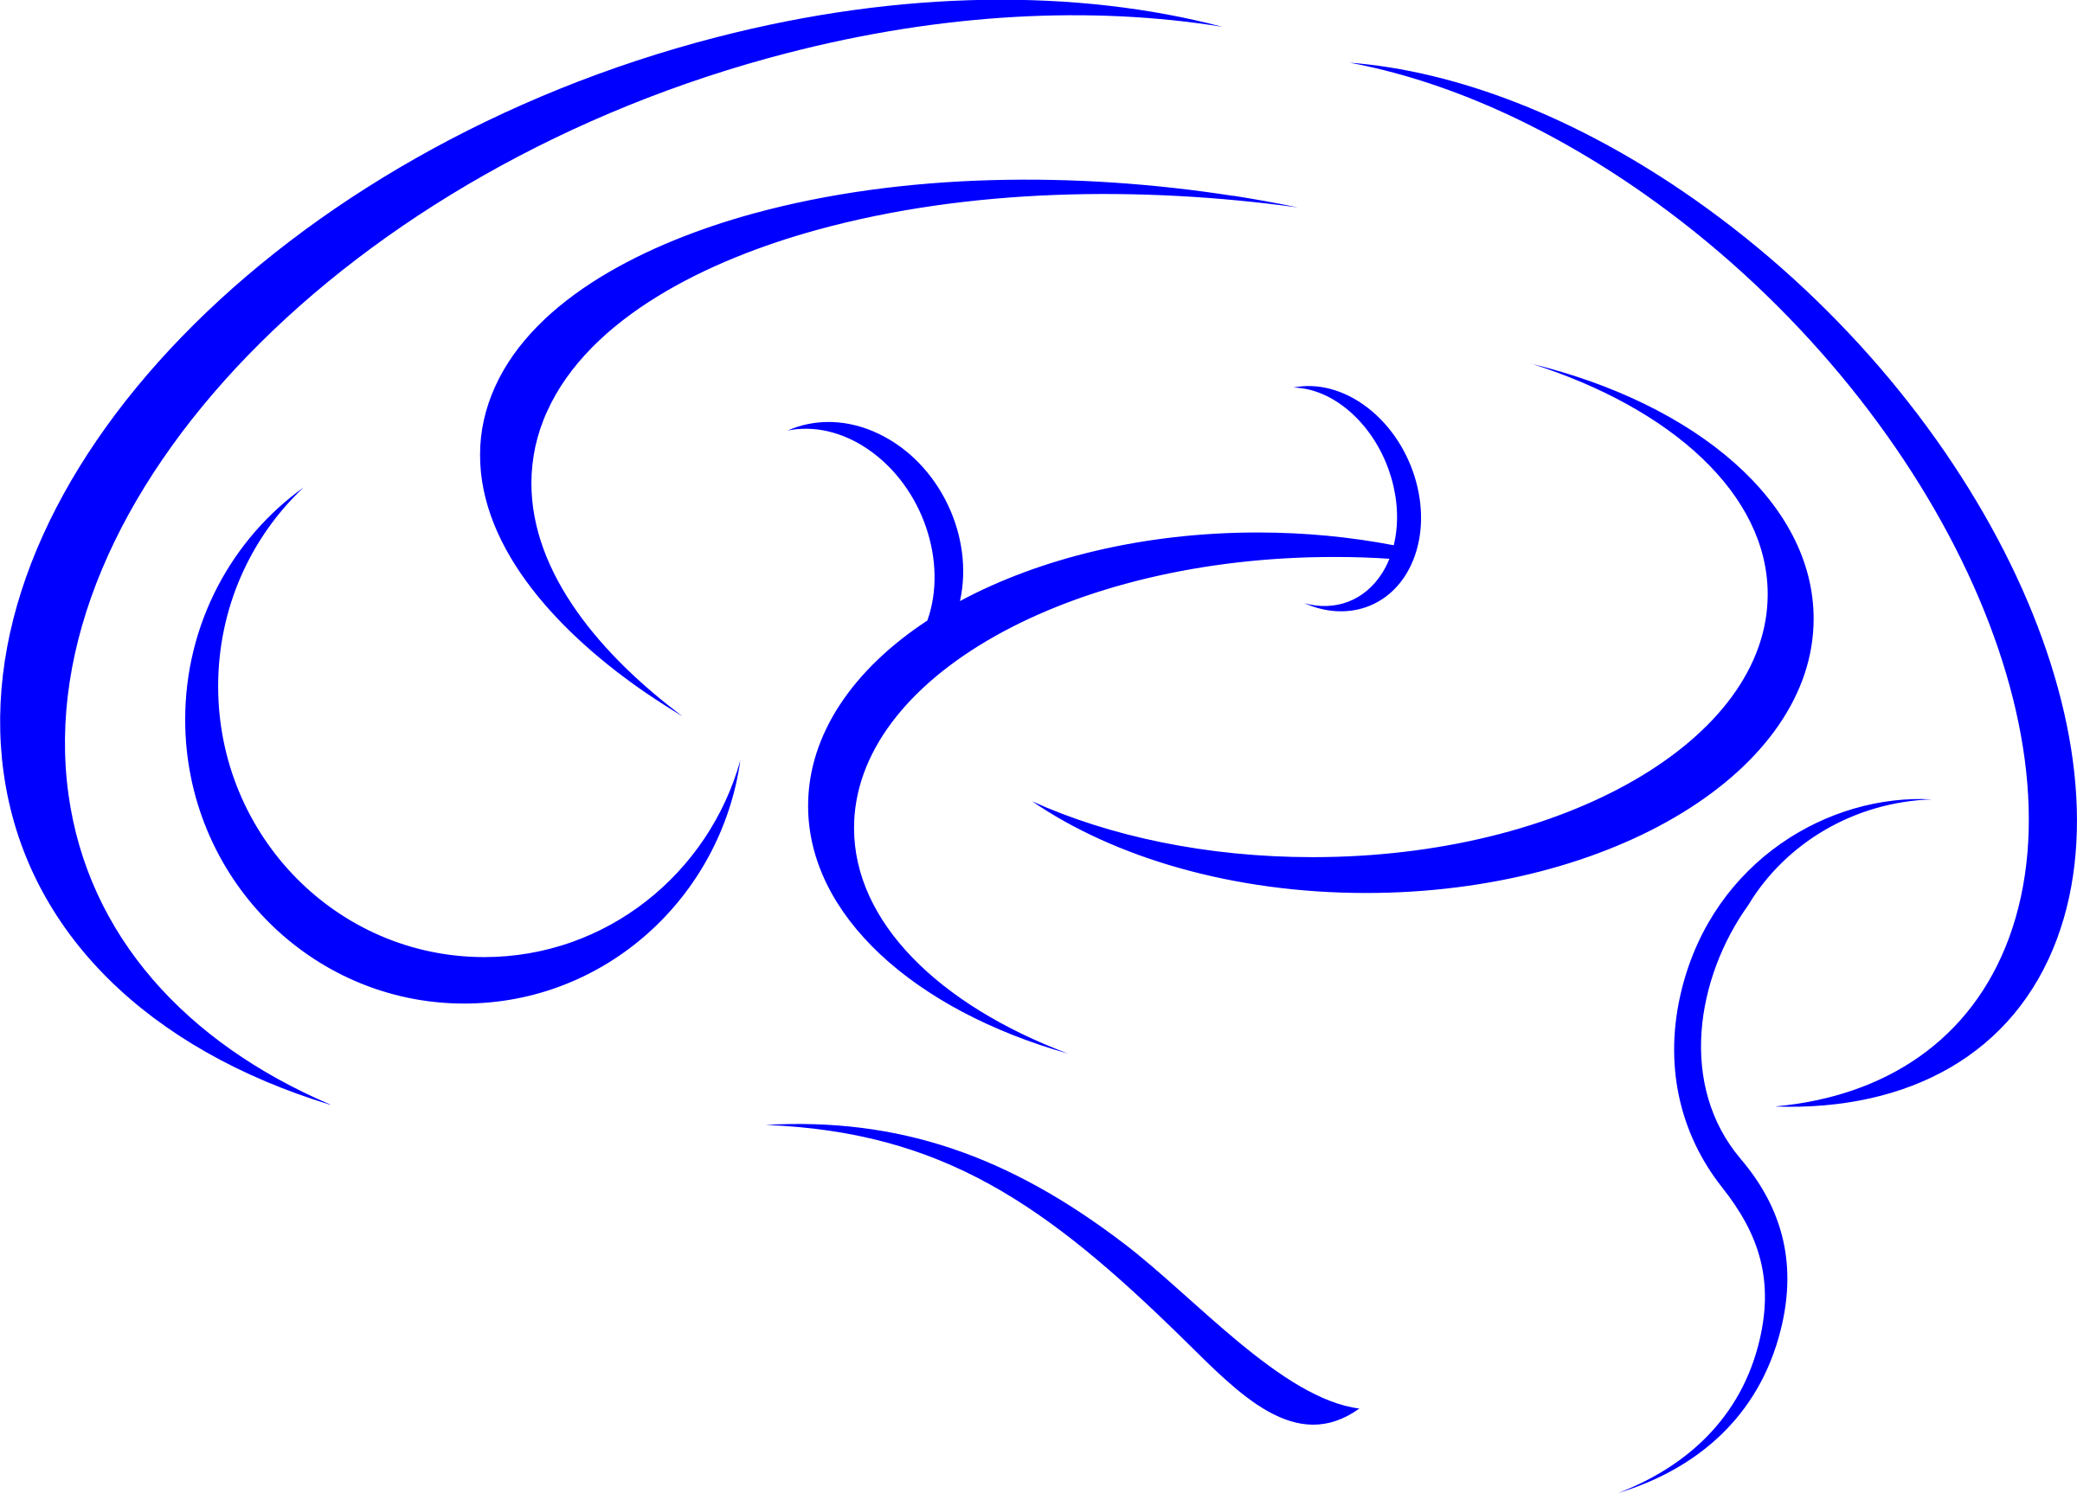

♥ ♥ ♥ ♥ ♥ ♥ ♥ ♥ ♥

**Checking Your Knowledge/Self-Study Activity**: please answer the questions as you research the following website and turn into ________________________ when completed.

Please navigate these websites to learn and study and demonstrate your learning by answering the following questions. Following to continue learning about Myasthenia Gravis, Aphasia and Alzheimer’s Disease. <https://www.ncbi.nlm.nih.gov/pmc/articles/PMC3505488/>; <https://www.ncbi.nlm.nih.gov/pmc/articles/PMC3726100/>; <https://myastheniagravisnews.com/myasthenia-gravis-causes/>

**Questions:**

1. **How does the Thymus Gland function influence our immune system?**
2. **What diagnostic test is used to diagnosis Myasthenia Gravis?**
3. **What is Myasthenia Gravis Crisis and what measures are often necessary?**
4. **Myasthenia Gravis symptoms include muscle weakness and 85% tend to have weakened muscle that control eye and eyelid movements, causing ocular weakness. What is the ice pack test?**