**◊◊◊** (insert your logo here) **2023 ◊◊◊**

**(**Connect to Values/Vision/Mission Statements insert here**)**

**Did you know that people throughout the world lose a leg every 30 seconds due to diabetes? You can check out the facts by going to** [**https://professional.diabetes.org/abstract/amputation-prevention-diabetic-patients**](https://professional.diabetes.org/abstract/amputation-prevention-diabetic-patients)**.**

**That is why we strive to stay informed about diabetes prevention, treatment management & Foot care. Do you know what type of mat this is above? What is the nurse assessing, when using a Tuning Fork to complete a foot exam? Have you heard of a smart insole? A smart shoe? A Smart Mat or a Harris Mat? How would an Infrared- Red non-Contact Thermometer help in routine care? Take time and check these out.**

**APRIL 2023**

Alcohol awareness Month/National Alcohol Screening 4/1

World Autism Awareness Month & Day 4/2

Cesarean Awareness Month

**Defeat Diabetes Month**

National Facial Protection Month

**Foot Health Awareness Month**

National Humor Month

IBS Awareness Month

Sexual Assault Awareness Month

Sexually Transmitted Infection Awareness Month

Sports Eye Safety Month

Oral, Head, Neck Cancer Awareness Month

World Parkinson’s Disease Awareness Month

**CELEBRATE YOUR COLLEAGUES!**

National Public Health Week 4/4-10

Administrative Week 4/27

National Occupational Therapy Month

World Day for Safety and Health at work 4/28

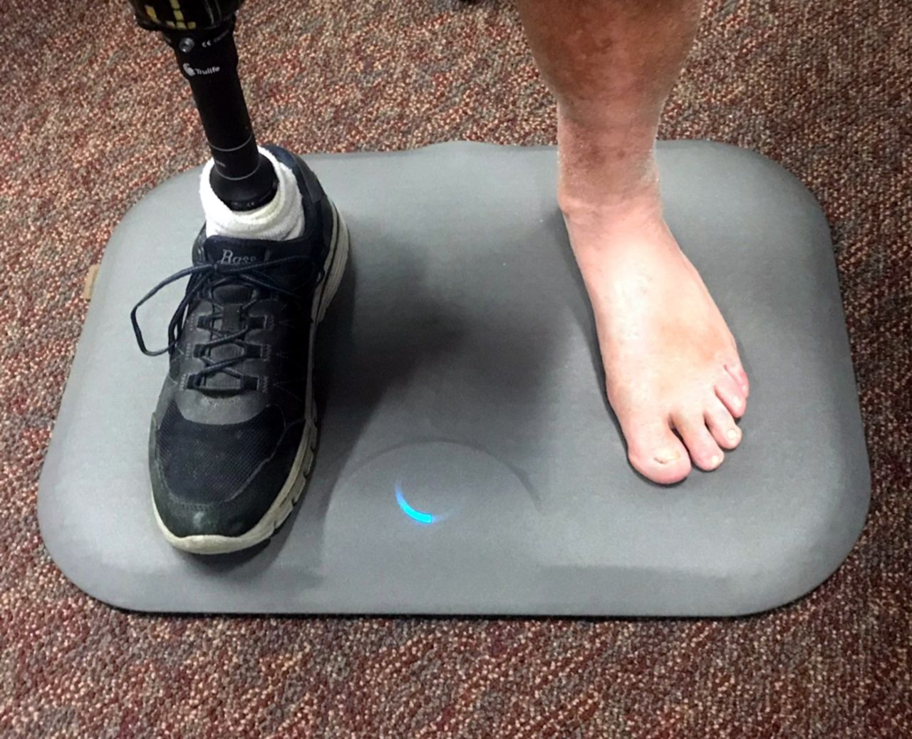

♥ ♥ ♥ ♥ ♥ ♥ ♥ ♥ ♥

**Checking Your Knowledge/Self-Study Activity**: please answer the questions as you research the following website and turn into _______________________________when completed.

Please navigate these websites to learn and study and demonstrate your learning by answering the following questions. <https://professional.diabetes.org/clinical-corner>; <https://www.ncbi.nlm.nih.gov/pmc/articles/PMC7291260/>; <https://jamanetwork.com/journals/jamainternalmedicine/fullarticle/191320>.

**Questions:**

1. **Is it now a standard of care for all people who have diabetes and smoke to be referred foot-care assessment?**
2. **What are severe metabolic complications of Diabetes Mellitus?**
3. **List at least four other tools available to help complete a thorough foot assessment.**