**◊◊◊** (insert your log) **2023 ◊◊◊**

Connect to Values/Vision/Mission Statements insert here)

**HAPPY NURSE DAY AND WEEK AND TO OUR NURSING PARTNERS WORKING IN SKILLED NURSING AND HOSPITALS! As there is much to learn this month, we should find equal time to CELEBRATE! Thank you all those caring for our seniors and promoting wellness.**

**Let’s take as we celebrate and learn together to refresh our skills on respiratory assessment. Challenge yourself and draw and outline the respiratory system anatomy as you were going to teach a student or a resident/family about asthma and how you assess the respiratory system.**

**Celebrate yourself and your knowledge by sharing your art with others or in a private journal or wherever you like to express yourself.**

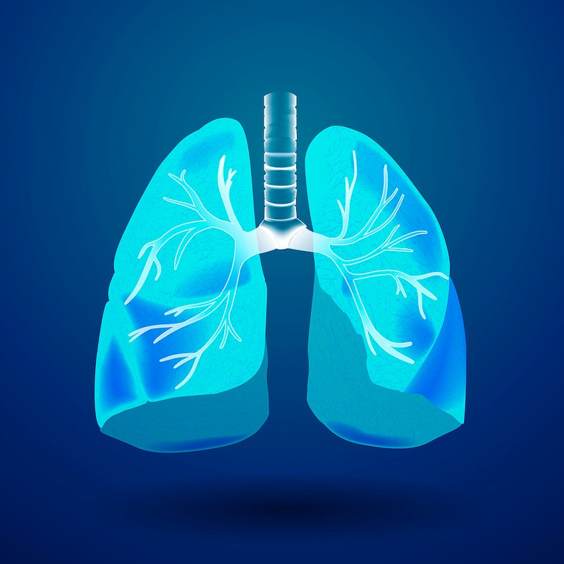

**MAY 2023**

**National Asthma & allergy Awareness Month**

Better Hearing and Speech Month

Better Sleep Month

High BP Awareness

Huntington’s Disease Awareness Month

Lupus Awareness Month

Mental Health Month

Dementia Action Week 5/16-22

National Hepatitis Awareness Month

National Osteoporosis Awareness Month

Skin Cancer Awareness Month

Stroke Awareness Month

**CELEBRATE YOUR COLLEAGUES!**

**NATIONAL NURSES DAY MAY 6**

**National Nurses Week**

**National Skilled Nursing Care Week**

**National Hospital Week**

Annual National Senior Health and Fitness Day

Employee Health and Fitness Month

Older Americans Month

National MH Month

♥ ♥ ♥ ♥ ♥ ♥ ♥ ♥ ♥

**Checking Your Knowledge/Self-Study Activity**: please answer the questions as you research the following website and turn into ______________________________________when completed.

<https://www.ncbi.nlm.nih.gov/books/NBK568760/>

**Questions:**

1. **What symptoms does a resident present with that may be suffering from asthma exacerbation?**
2. **Following assessment how what monitoring interventions are needed?**
3. **When do you notify a physician or seek help?**
4. **What is the biggest pitfall noted in this book about using a nebulizer mask?**